EXERCISE – Inflammation and cancer

Task: Complete the figure by filling the empty boxes and write a figure legend

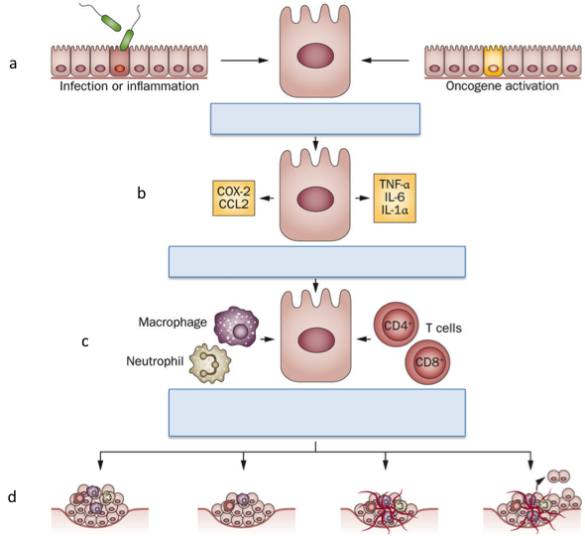

Title: …

Brief summary of the figure (1-2 sentences): …

Detailed figure legend
A: …

B: …

C: …

D: ….

